TUTORIAL 1
Question 1
Answer-

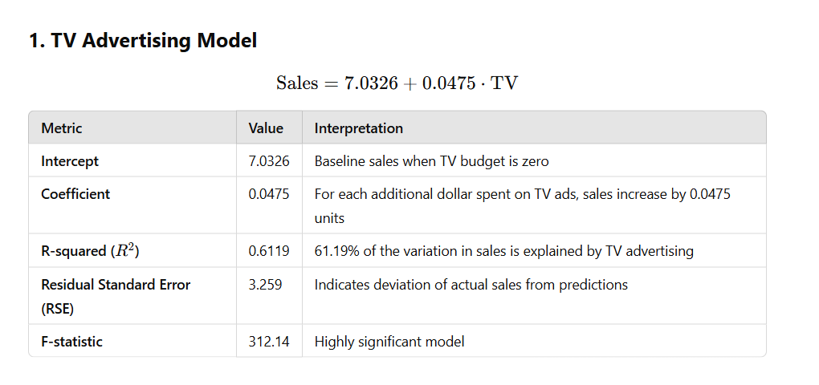

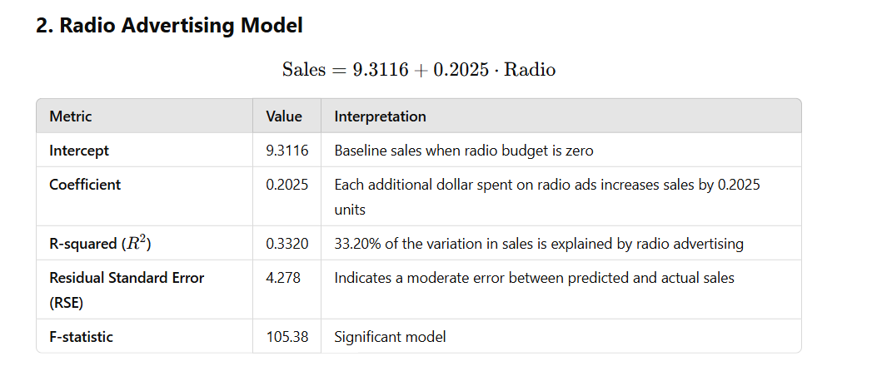

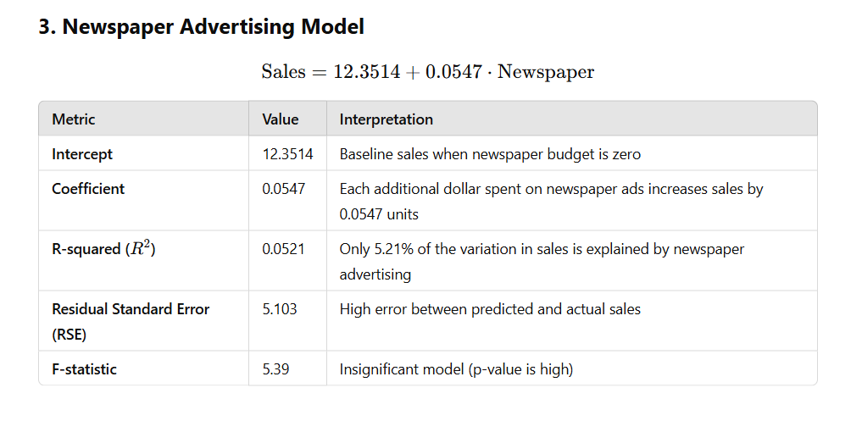

This analysis highlights that TV and radio are effective advertising channels for increasing sales, while newspaper advertising appears to have little impact.

